November XX, 2021

MEMORANDUM NO: 2021-XXX

TO: Members, Board of Regents
The Texas A&M University System

THROUGH: Ray Bonilla, General Counsel
The Texas A&M University System

SUBJECT: Texas Education Code 51.252 Compliance Report

During the 86th Legislative Session, SB 212/HB 1735 was passed requiring that at least once during each fall or spring semester, the Chief Executive Officer at institutions of higher education must submit to their governing body a report of complaints of sexual harassment, sexual assault, dating violence, or stalking, as defined in the Texas Education Code. This legislation also requires that members post their reports on their respective website, which was completed at the end of October.

Attached please find the report for System-wide compliance with Texas Education Code 51.252. The report is for the 2020-2021 academic year and applies only to incidents made by employees in The Texas A&M University System. This report does not include reports made by students and third parties because the new law focuses the requirement on reports from employees. Along with the combined System report, you will also find a detailed breakdown by member.

Because of the number of complaints we are not able to investigate is substantial, you will note we included the following explanation in the report:

- The complaint describes an incident that took place before the complainant was a student or employee in the A&M System, e.g. incidents that occurred in middle school or high school, or at another institution/agency;

- The complaint is submitted anonymously and critical information needed to investigate the complaint is not available, or;

(c) The complainant specifically asks that no investigation be pursued.

If you have questions, please feel free to reach out to Ray Bonilla or myself.
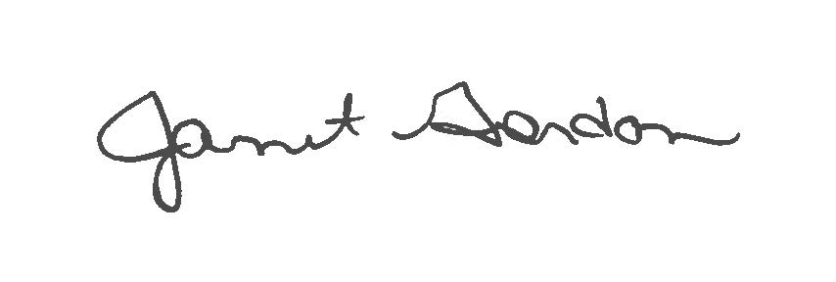

Janet Gordon
System Ethics and Compliance Officer

Attachment

cc: Chancellor John Sharp
Mr. Billy Hamilton, Deputy Chancellor and Chief Financial Officer
Ms. Vickie Spillers, Executive Director, Board of Regents
Chief Executive Officers
Chief Compliance Officers

